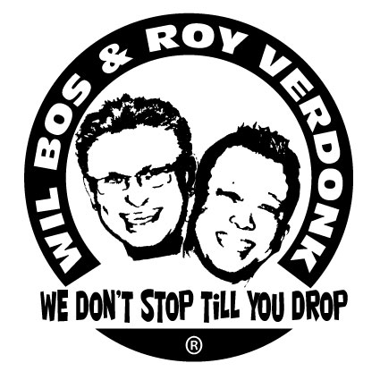
Day Dreams

Choreographers : Wil Bos & Roy Verdonk (July 2011)
Level : Intermediate
Dance : 64 counts, 4 wall
Music : Raphael Saadiq – Day Dreams
Intro : 32 counts on main vocals
FWD POINT R, SIDE POINT, SAILOR ¼ TURN R, FWD POINT L, SIDE POINT L, SAILOR ¼ TURN LEFT
1-2 Touch Right forward, Touch Right to Right side
3&4 Cross Right behind Left, ¼ turn Right step Left to Left side, Step Right to Right side
5-6 Touch Left forward, Touch Left to Left side
7&8 Cross Left behind Right, ¼ turn Left step Right to Right side, Step Left to Left side (12.00)
CHARLESTON STEPS R & L, FWD R, PIVOT ½ TURN LEFT, RUNNING STEPS R,L,R
1-2 Touch Right forward, Step Right back
3-4 Touch Left Back, Step Left forward
5-6 Step Right forward, Pivot ½ left
7&8 Short runs (Right, Left, Right) (06:00)
FWD POINT L, SIDE POINT L, SAILOR ¼ TURN LEFT, FWD POINT R, SIDE POINT R, SAILOR ¼ TURN RIGHT
1-2 Touch Left forward, Touch Left to Left side
3&4 Cross Left behind Right, ¼ turn Left step Right to Right side, Step Left to Left side
5-6 Touch Right forward, Touch Right to Right side
7&8 Cross Right behind Left, ¼ turn Right step Left to Left side, Step Right to Right side (06.00)
CHARLESTON STEPS L,R,L, FWD, PIVOT ½ TURN RIGHT, RUNNING STEPS L,R,L
1-2 Touch Left forward, Step Left back
3-4 Touch Right Back, Step Right forward
5-6 Step Left forward, Pivot ½ right
7&8 Short runs (Left, Right, Left) (12:00)
MODEFIED SYNCOPATED JAZZ BOX ¼ RIGHT, STEP FORWARD L, STEP HEEL SWIVLE RIGHT, STEP HEEL SWIVLE LEFT
1-2 Cross Right over Left, ¼ turn right step Left back
&3-4 Close Right next to Left, Step Left forward, Step Right forward
5&6 Step Left forward, Turn Left heel outward to left, Turn Left heel back to right
7&8 Step Right forward, Turn Right heel outward to right, Turn Right heel back to left (03:00)
ROCK L, RECOVER R, ½ SAILOR STEP LEFT, TOUCH FLICK RIGHT HEEL, TOUCH FLICK LEFT HEEL
1-2 Rock Left forward, Recover
3&4 Cross Left behind Right, ½ turn Left step Right to Right side, Step Left to Left
5&6 Touch Right forward, Flick Right heel back right, Close Right next to Left
7&8 Touch Left forward, Flick Left heel back left, Close Left next to Right (09:00)
1/2 TURN L TOE STRUT R BACK, LEFT COASTER STEP, SYNCOPATED LOCK STEPS
1-2 ½ Turn Left, Toe strut Right back
3&4 Step Left back, Close Right next to Left, Step Left forward
5&6 Step Right forward, Lock Left behind Right, Step Right forward
&7&8 Step Left forward, Lock Right behind Left, Step Left forward, Step Right forward (03.00)

ROCK L, RECOVER R, COASTER STEP L, STEP, PIVOT ½ LEFT, JUMPS FWD
1-2 Rock Left forward, Recover
3&4 Step Left back, Close Right next to Left, Step Left forward
5-6 Step Right forward, Pivot ½ L
7&8 Short jumps forward with both feet (3 jumps) (09.00)

Start again smile ☺ and have fun

